Train and Validation split logic
train_list = []
val_list = []

for ts in darts_df_with_static_covariates:
train = ts.slice(pd.Timestamp('2023-04-01'), pd.Timestamp('2025-11-01'))
val = ts.slice(pd.Timestamp('2024-12-01'), pd.Timestamp('2026-05-01'))

train_list.append(train)
val_list.append(val)

train_future_covariates_list = []
validation_future_covariates_list = []

for ts in darts_df_with_future_covariates:
train = ts.slice(pd.Timestamp('2023-04-01'), pd.Timestamp('2025-11-01'))
val = ts.slice(pd.Timestamp('2024-12-01'), pd.Timestamp('2026-05-01'))
train_future_covariates_list.append(train)
validation_future_covariates_list.append(val)

Train and validation performance
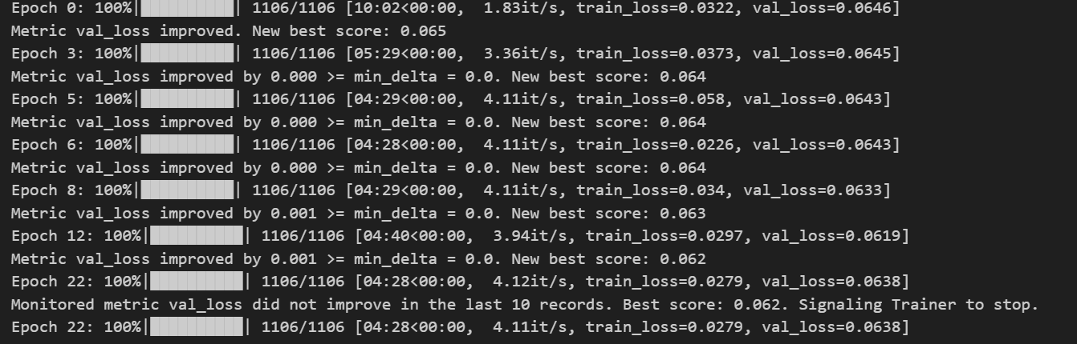

Lookahead and Lookback data
#Step 1 - Preparing the lookback data for the model
lookback_data_pandas_df = prediction_df.loc[((prediction_df.index>='2024-12-01')&(prediction_df.index<='2026-05-01')),target_plus_static_cols]

#Step 2 - Preparing the lookahead data for the model
lookahead_data_pandas_df = prediction_df.loc[((prediction_df.index>='2024-12-01')&(prediction_df.index<='2026-11-01')),static_plus_future_cov]

#Step 3 - Creating the darts time-series object from lookback data for the model
lookback_data_darts_df = TimeSeries.from_group_dataframe(df=lookback_data_pandas_df,group_cols=["PARENT_DEALER_CODE_MODEL_FAMILY"],static_cols=static_covariates,value_cols=["NET_SALES"],freq='MS')

#Step 4 - Creating the darts time-series object from lookahead data for the model
lookahead_data_darts_df = TimeSeries.from_group_dataframe(
df=lookahead_data_pandas_df,
group_cols="PARENT_DEALER_CODE_MODEL_FAMILY",
static_cols=static_covariates,
value_cols=future_covariates,
freq='MS'
)

- Final output

MONTH_NAME | TFT_PREDICTED_MONTHLY_SALES | AVG_MONTHLY_SALES | UNDERPREDICTION_BY
June | 386790.75 | 444836 | -13.05%
July | 350689.28 | 375676.75 | -6.65%
August | 335238.94 | 373306.5 | -10.20%
September | 316078.56 | 327632 | -3.53%
October | 635328.19 | 1121534.25 | -43.35%
November | 596278.99 | 720126.75 | -17.20%

